ST. GEORGE’S CATHOLIC PRIMARY SCHOOL & NURSERY

Personal, Social, Health and Economic Policy (PSHE)
&
Relationship, Sex and Health Policy (RSHE)

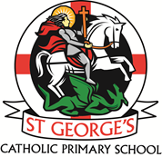

2025-2026

St George’s Relationship, Sex and Health Policy. (RSHE)
Mission Statement
‘To learn with kindness, respect and friendship through God’s love.’

- To enable every individual (made in the image and likeness of God) to learn, grow and reach their full potential.
We will do this by:
- Providing high quality, engaging lessons and learning experiences.
- Encouraging individuals to excel in all areas of school life.
- Valuing, sharing and celebrating all achievements - (Weekly celebration assemblies)
- Providing extra-curricular activities to extend learning to outside the classroom. (Sports, Music clubs, Forest School etc)
- Providing the opportunities for assessment to enhance future learning. (Self assessment, peer assessment.)

- We aim to be a loving Christian family living the values of the Gospel.
We will do this by:
- Providing positive role models and giving opportunities to highlight and reward good examples of living a Christian life from the children. (Award assemblies)
- Providing opportunities to focus on a weekly Gospel value through well planned, daily, collective worship sessions.
- Regularly reinforcing expected behaviours throughout the school and encouraging children to reflect and challenge their own behaviours. (Behaviour support, Buddy systems, peer mentoring.)

- To seek to make a difference through developing caring relationships with the local and wider community.
We will do this by:
- Valuing our link with the parish family and supporting the delivery of the ‘With you Always’ program.
- Providing regular school liturgies and celebrations. To further the link with the Parish.
- Engaging with parents to make them feel welcome and supported.
- Continuing to fundraise for both local and global charities in a variety of ways.
- Participating in MADCOS events. (Maghull and district cluster of schools) - Training events, sporting events etc.

Overview:
Statutory Relationships Education and Health Education came into effect at key stage 1 and 2 from September 2020. This statutory content — sometimes referred to as ‘RSHE’ — makes up the majority of our school’s PSHE education. The aim of this policy is to show how the statutory requirements for both PSHE and RSHE are delivered to our children and are woven through our cross curricular approach including Come and see -RE, Journey in Love -RSE as well as science, PE and One Decision – PSHE.

Rationale
‘I HAVE COME THAT YOU MIGHT HAVE LIFE AND HAVE IT TO THE FULL’
(Jn.10.10)

We are involved in Relationship, Sex and Education (RSE) precisely because of our Christian beliefs about God and about the human person. The belief in the unique dignity of the human person made in the image and likeness of God underpins the approach to all education in a Catholic school. Our approach to RSE therefore is rooted in the Catholic Church’s teaching of the human person and presented in a positive framework of Christian ideals.
At the heart of the Christian life is the Trinity; Father, Son and Spirit in communion, united in loving relationship and embracing all people and all creation. As a consequence of the Christian belief that we are made in the image and likeness of God, gender and sexuality are seen as God’s gift, reflect God’s beauty, and share in the divine creativity. RSE, therefore, will be placed firmly within the context of relationship as it is there that sexuality grows and develops.
Following the guidance of the Bishops of England and Wales and as advocated by the DFE (and the Welsh Assembly Government) RSE will be firmly embedded in the PSHE/RSHE framework as it is concerned with nurturing human wholeness and integral to the physical, spiritual, emotional, moral, social and intellectual development of pupils. It is centred on Christ’s vision of being human as good news and will be positive and prudent, showing the potential for development, while enabling the dangers and risks involved to be understood and appreciated.
All Relationship, Sex and Health Education RSHE will be in accordance with the Church’s moral teaching. It will emphasise the central importance of marriage and the family whilst acknowledging that all pupils have a fundamental right to have their life respected whatever household they come from. It will also prepare pupils for life in modern Britain.
Aim
St George’s Catholic Primary School, aims to provide a suitable programme that follows the statutory need to include RSHE into their curriculum from September 2020 which meets the ethos of its Catholic identity and mission.
The purpose of this Relationship, Sex and Health Education (RSHE) policy is to set out the ways in which the school’s provision supports pupils through their spiritual, moral, social, emotional and physical development, and prepares them for the opportunities, responsibilities and experiences of life growing up in today’s world.
Our School’s mission embraces the spiritual, physical, intellectual, emotional, moral and social development of children and young people, and through an agreed approach to Relationship and Sex Education (RSE) using the Archdiocesan recommended resource ‘Journey In’ Love 2020 we believe that we can promote the development of the whole child, so that children can grow in virtue, wisdom and stature, understanding both the emotional, social and physical aspects of growing spiritually, as well as moral aspects of relationships within a context of a Christian vision for the purpose of life.
The other aspects of the statutory curriculum intent will be met by using and amending the ‘One Decision’ PSHE scheme of work to develop pupil’s knowledge, skills and attributes they need to keep themselves healthy and safe, and prepared for life and work. We aim to develop skills and attributes such as resilience, self esteem, risk management, team working and critical thinking.

St George’s staff have undertaken intensive mapping of all curriculum areas in order to ensure that all areas of PSHE are taught effectively throughout the child’s school journey. Any gaps or additional needs based on the current cohort of pupils have then been identified and planned for accordingly for example mental health needs following the pandemic and basic first aid training for all pupils.

The other aspects of the Statutory curriculum intent will be met by within Come and See (RE), PSHE and Science curricula. (See appendices at end of document which incorporates Come and See (Appendix 2), DFE Statutory Relationships and Statutory Science (Appendix 3) and an overview of other resources mapped across each Year Group (Appendix 4))

The Purpose
The aims of Relationship, Sex and Health Education (RSHE) at St George’s Catholic Primary School are to:
- Provide a framework in which sensitive discussions can take place.
- Help pupils develop feelings of dignity, self-worth, self-respect, confidence and empathy.
- Prepare pupils for puberty and give them an understanding of sexual development and the importance of health and hygiene.
- Create a positive culture around issues of sexuality and relationships.
- Teach pupils the correct vocabulary to describe themselves and their bodies.

Statutory Requirements
At St George’s, we must provide Relationships Education to all pupils as per section 34 of the Children and Social work act 2017.
In teaching Relationship and Sex Education, we must have regard to Catholic Education Service guidance issued by the Bishops Conference of England and Wales 2017.
The statutory guidance from the Department for Education issued under Section 80A of the Education Act 2002 and section 403 of the Education Act 1996 Appendix A
The statutory guidance from the Department for Education Equality Act 2010.
Policy Development
This policy has been developed in consultation with staff, pupils and parents. The consultation and policy development process involved the following steps:
- Review: Pete Chapman (Head Teacher), Sean Dillon (AHT) and TM (RE lead) reviewed the policy, referencing DfE statutory guidance and guidance from the Archdiocese of Liverpool.

2. Staff consultation: During a staff meeting on 14/6/24 all school staff were given the opportunity to look at the policy and make any recommendations they believe should be part of our work. This helped us to plan how certain topics were being taught and whether to separate girls and boys for areas of learning.

3. Parent/stakeholder consultation: Parents/carers were invited to complete a questionnaire on 15/5/25 after having the opportunity to attend a workshop in school highlighting the main teaching content for each year group. They were then invited to send any questions or concerns back to school. The comments received helped to ensure that as a school, we met parents’ needs and concerns whilst ensuring that the statutory content and guidance is taught.

4. Pupil consultation: Each class, relative to their age appropriate understanding, was asked about what exactly they want from their Relationship, Sex and Health Education. Each class spent an age appropriate amount of time discussing and highlighting any questions or points pupils would like to cover during this work. This took place during the week of 14/6/24. As with parent/carer contributions, these comments helped to meet pupil needs whilst ensuring statutory content and guidance is taught.

5. Ratification: once this process was followed, the policy was shared with governors and ratified.

Definition
Relationship, Sex and Health Education involves a combination of sharing information, and exploring issues underpinned by our Catholic values.
Relationship Sex and Health Education is about the emotional, social and cultural development of pupils, and involves learning about personal relationships, sexual health, sexuality, healthy lifestyles, diversity and personal identity.

Curriculum
We have developed our curriculum with recommendations from the Archdiocesan Education Department to ensure that they meet with Catholic Church teaching.
After consultation with parents Relationship Sex Education will be covered using the Archdiocesan recommended resource ‘Journey In Love’ 2020 (see appendix 5) this includes *sexual intercourse at Year 6. (See right of withdrawal)
We have considered the age, stage and feelings of pupils and have consulted with parents and staff to ensure we are offering a quality curriculum which is adequately catered to meet their needs.
We have adopted the One Decision scheme of work for PSHE and mapped the coverage throughout school from reception to year 6. Taking into consideration the needs of each cohort of children and adapting accordingly.
If pupils ask questions outside the scope of the curriculum, teachers will respond in an appropriate manner so they are fully informed and do not seek answers online.
Information from Public Health England is regularly downloaded and analysed to highlight issues regarding the health and well-being, both physical and mental, of our pupils. This analysis feeds into the work being completed by each year group so that we are constantly evolving to support the needs of our pupils.

Delivery of Relationship, Sex and Health Education (RSHE)
Relationship and Sex Education (RSHE) is taught both discretely and within the Personal, Social and Health Education. (PSHE) lessons. Some aspects of the RSHE curriculum may be touched upon in other lessons as it shares links with Religious Education, science and Physical Education.

Our RSHE will ensure that content is relevant to the age, experience and maturity of pupils.
The new statutory guidance for relationship education focuses on teaching the fundamental building blocks and characteristics of positive relationships including:
- Families and people who care for me.
- Caring friendships
- Respectful relationships.
- Online relationships.
- Being safe
These areas of learning are taught within the context of ‘Family life’ and could include married or single parent families, same sex parents, families headed by grandparents, adoptive parents, foster parents / carers amongst other structures, along with reflecting sensitively that some children may have a support structure around them (for example: looked after children or young carers.)

As a school, we promote equality of opportunity and foster good relations. Our school environment uniformly applies values of inclusion and respect to all pupils and their families. All staff are proactive in promoting positive relationships and receive regular training.

Equal Opportunities
All pupils have access to the RSHE curriculum. Where pupils have specific educational needs, arrangements for support from outside agencies and support staff are made to ensure these pupils have an appropriate, differentiated curriculum.

Roles and responsibility
The Governing Body
The governing body will approve of the RSHE policy and hold the headteacher to account for its implementation.

The Headteacher
The headteacher is responsible for ensuring that RSHE is taught consistently across the school and managing requests to withdraw pupils from the non-statutory element of Relationship and Sex Education in year 6 * (see right of withdrawal)
Staff
Staff do not have the right to opt out of teaching RSHE as this forms part of the Teaching Standards. Any staff who have concerns about teaching RSHE are encouraged to discuss this with the headteacher.
Staff are responsible for:
- Delivering RSHE in a sensitive way which complies with Church teaching.
- Modelling positive attitudes to RSHE.
- Monitoring progress.
- Responding to the needs of individual pupils.
- Responding appropriately to pupils whose parents wish to withdraw them from the non-statutory components of RSE.
Pupils
Pupils are expected to engage fully in RSHE and, when discussing issues related to RSHE, treat others with dignity, respect and sensitivity.

Parents right to withdraw
Parents have a right to withdraw their child from the non-statutory component of sex education in year 6. This is where sexual intercourse is taught discretely as part of the physical aspect within ‘Journey in Love’ the Archdiocesan recommended resource.
Requests for withdrawal should be made in writing and addressed to the headteacher. The headteacher will discuss the request with parents and take appropriate action. Alternative work will be given to pupils who are withdrawn from RSE.
Parents do not have the right to withdraw their child from Statutory Relationships Education as set out in the DFE guidance 2020.

Monitoring arrangements
The delivery of RSHE is monitored by SLT and RSHE lead by undertaking learning walks, staff and pupil consultations, planning and work scrutinies and questionnaires.
Pupils’ development in RSE is monitored by class teachers as part of our internal informal assessment systems. This policy will be agreed annually and reviewed every three years as per the policy updating cycle.
Resources
One decision scheme of work
Journey in Love
Come and see
Young Minds Mental Health www.youngminds.org.uk
National Anti-Bullying Website www.anti-bullyingalliance.org.uk
Internet safety www.purplemash.com
Road safety www.roadsafetyweek.org.uk
NSPCC www.nspcc.org.uk

Appendix 1
Primary Relationships Education Statutory Learning Opportunities

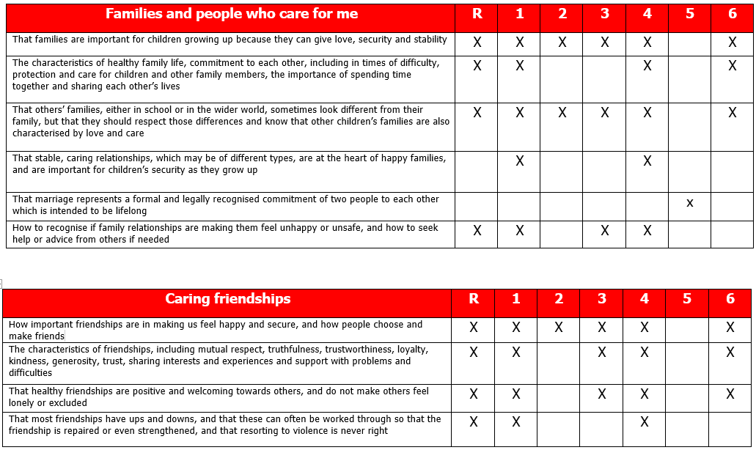

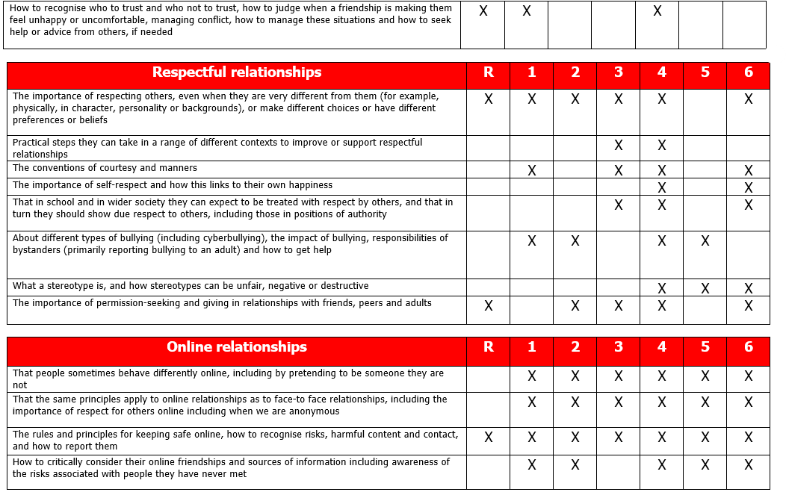

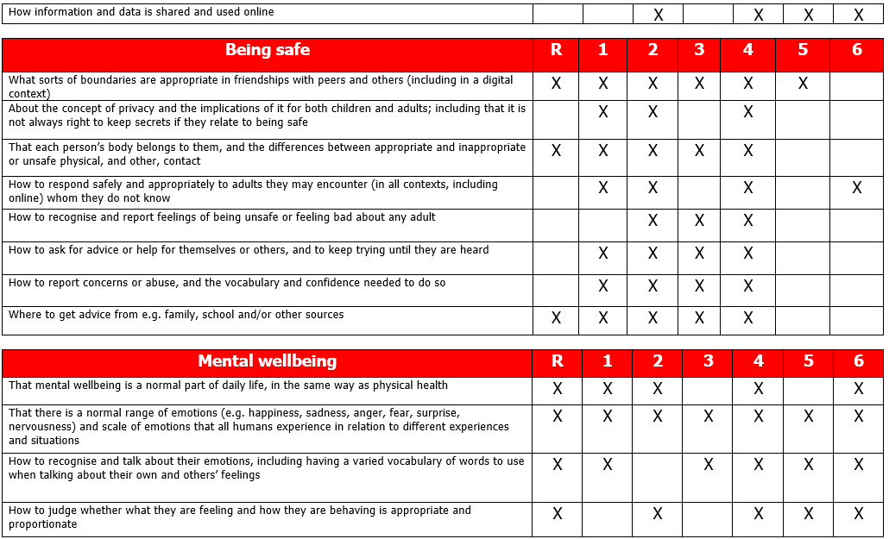

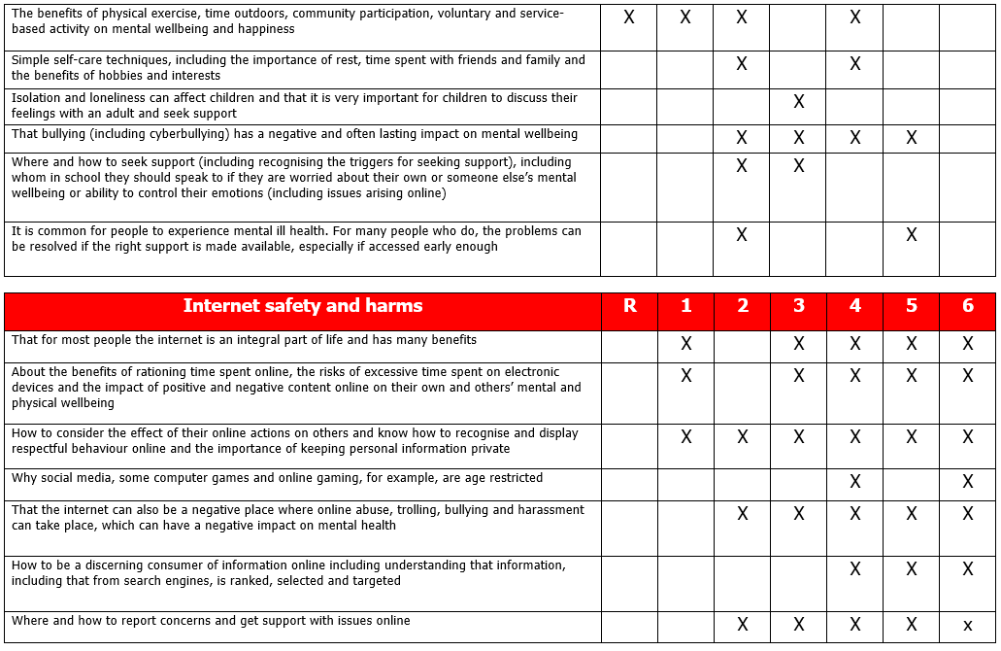
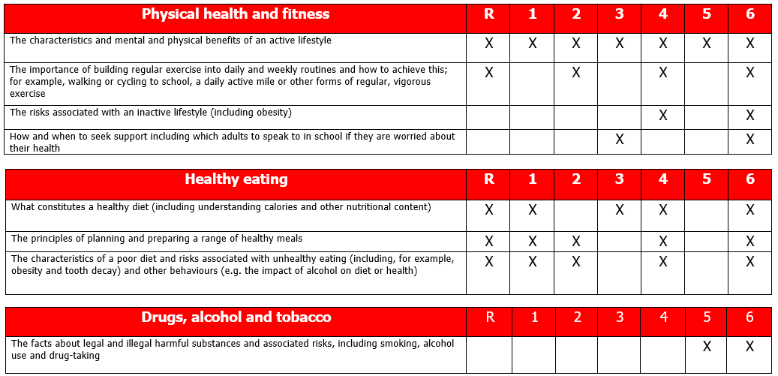

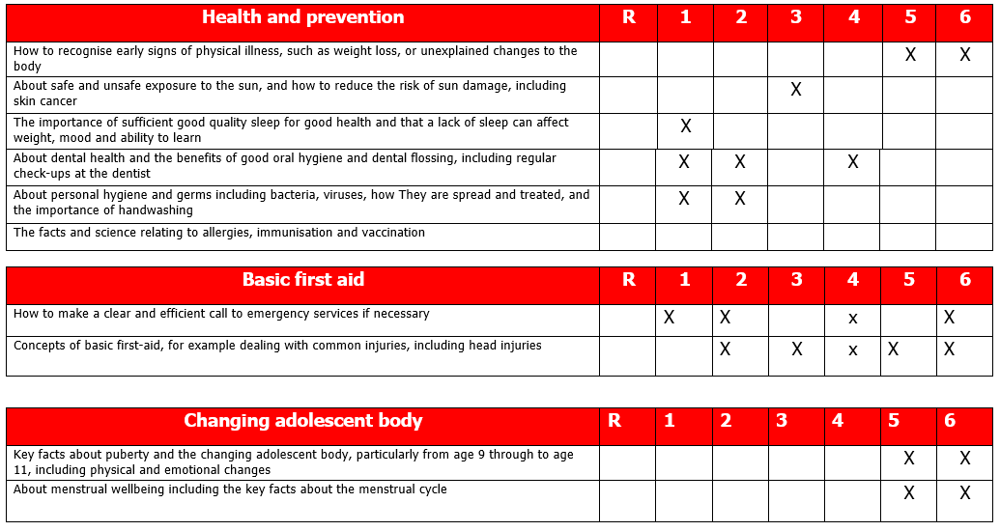

Appendix 2
Come and See and Relationship and Sex Education


Introduction The following is intended as a guide for linking Relationship and Sex Education with Come and See. Some of these aspects might be covered in the EXPLORE section where the topic is being introduced, starting with the pupil’s own experience, and extending into the REVEAL and RESPOND sections. Some ideas may be used in the REVEAL process where the teaching is explicitly concerned with Scripture and the teaching of the Church. Some topics offer more explicit teaching to develop ideas about Relationship and Sex Education, some less so.

Another way of using this section is when teaching Religious Education which occurs in other aspects of the curriculum e.g. Science, P.E, PSHE etc.
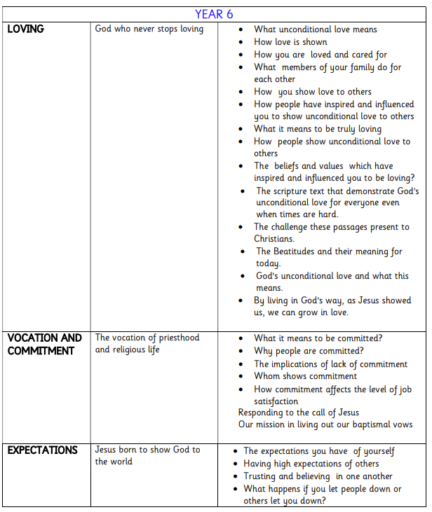
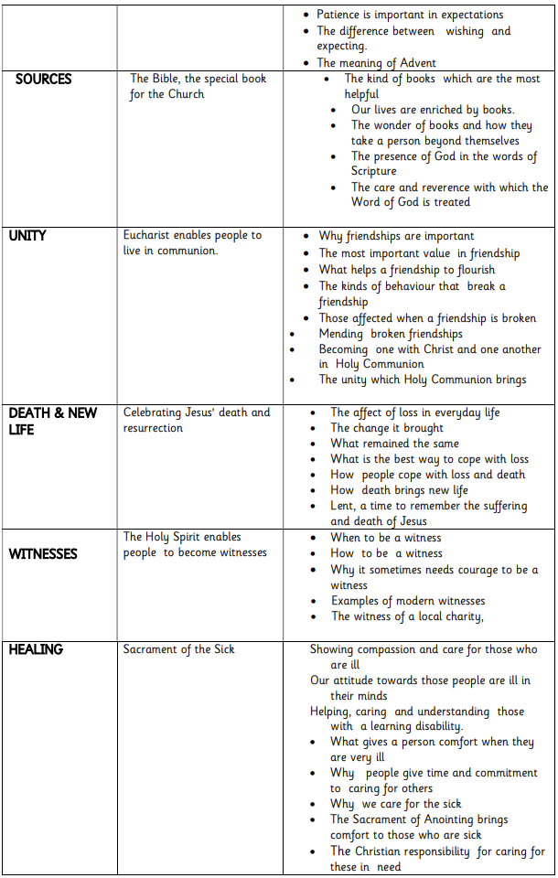

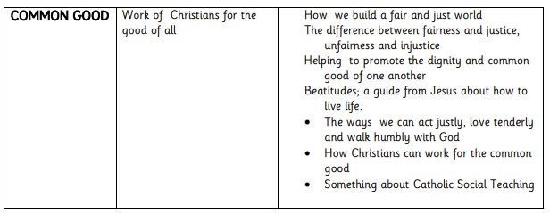

Appendix 3
Statutory Science Curriculum Early Years Foundation Stage children learn about life cycles.

Through on-going personal, social and emotional development they develop the skills to form relationships and think about relationships with others.

In Key Stage 1 children learn:

• That animals, including humans, move, feed, grow and use their senses and reproduce
• To recognise and compare the main external parts of the bodies of humans
• That humans and animals can reproduce offspring and these grow into adults
• To recognise similarities and differences between themselves and others
• To treat others with sensitivity

In Key Stage 2 children learn:

• That the life processes common to humans and other animals including nutrition, growth and reproduction
• About the main stages of the human life cycle

Appendix 4:
RSHE, personal development, wellbeing and citizenship Overview

At St George’s Catholic Primary School, the physical and emotional well-being of our children is a priority. We place a great deal of importance on RSHE, personal development, wellbeing and citizenship as a Catholic school and it is embedded in our ethos as defined in the Mission Statement and Aims of the school:

Our Mission Statement: ‘To learn with kindness, respect and friendship through God’s love.’

We nurture and educate our pupils in order to help them develop the knowledge, understanding and skills needed to live happy, healthy and successful lives, now and in the future. Central to our RSHE, personal development, wellbeing and citizenship teaching and learning is the promotion and nurturing of our pupils spiritual, moral, social and cultural development. These aspects of the curriculum are taught through a range of implicit and explicit learning opportunities and is embedded throughout the curriculum.

Whole school events such as assemblies, enrichment activities, trips and visits/visitors and Church services throughout the year also enhance this provision further. Throughout the year, whole school assemblies focus on each of the British Values as part of our ongoing exploration of our School Values. Many of these values are reinforced through our Religious Education programme and children have regular opportunities to explore them further through celebration of the word.

Relationships Education
The focus in primary school should be on teaching the fundamental building blocks and characteristics of positive relationships, with particular reference to friendships, family relationships, and relationships with other children and with adults.

Physical health and mental wellbeing
The aim of teaching pupils about physical health and mental wellbeing is to give them the information that they need to make good decisions about their own health and wellbeing. It should enable them to recognise what is normal and what is an issue in themselves and others and, when issues arise, know how to seek support as early as possible from appropriate sources.

‘All of these subjects should be set in the context of a wider whole-school approach to supporting pupils to be safe, happy and prepared for life beyond school.’

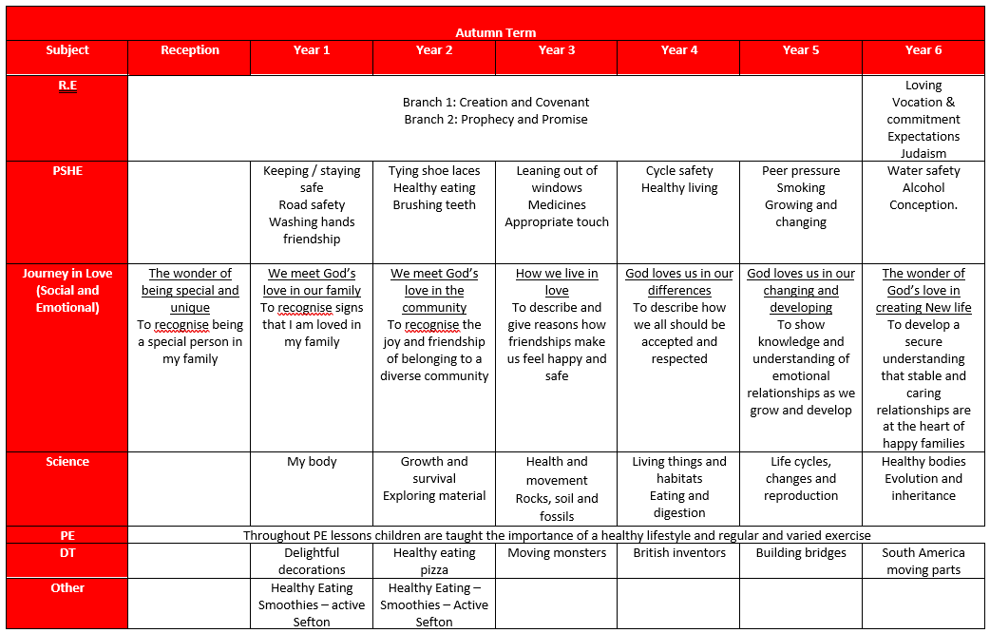

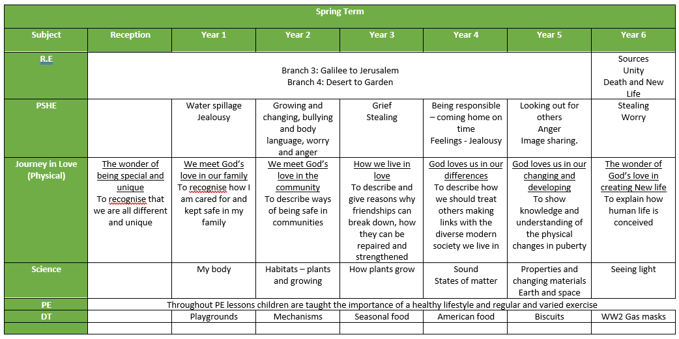

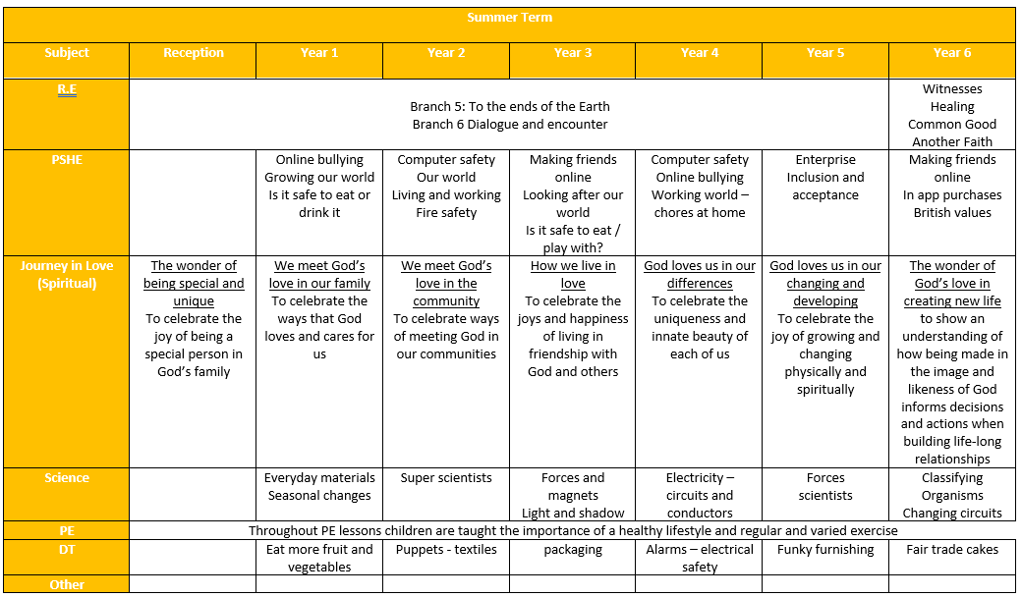

Appendix 5
Relationships and Sex Education A Summary Grid for Journey in Love 2020

