EYFS/KS1 History and Geography Curriculum Overview
Year Group | Subject | Autumn 1 | Autumn 2 | Spring 1 | Spring 2 | Summer 1 | Summer 2
EYFS | History | Our families and  those special to  us  Concept of time passing – parts  of the day and  days of the week | Our family  Christmas  traditions | Royals  (past and  present)  Toys and games (past and  present)  Frank Hornby |  | Myths and  legends –  generations and  the past | The jobs our  families do  What we would  like to do when we grow up
 | Geography | Daily weather  Spatial sense –  moving around our school and  planning routes | Daily weather  Treasure maps | Daily weather  Exploring our  local area | Daily weather | Daily weather  Introduction to  continents with focus on Africa  Directions and  Routes | Daily weather  My house, local  area Maps  Our Earth
Year 1 | History | Travel and Transport | The Gunpowder Plot |  |  | Kings and Queens | Local History- Maghull
 | Geography |  |  | Our School | Our Local Area
Year 2 | History |  | The Great Fire of London |  | Nurturing Nurses |  | Local History- The Beatles
 | Geography | What a Wonderful World |  | Sensational Safari |  | Magical Mapping
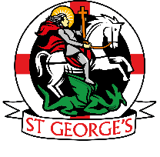
St. George’s Catholic Primary School
To learn with kindness, respect and friendship through God’s love

