KS2 History and Geography Curriculum Overview
Year Group | Subject | Autumn 1 | Autumn 2 | Spring 1 | Spring 2 | Summer 1 | Summer 2
Year 3 | History | Stone Age to Iron Age  30,000 BC- AD 43 |  | Ancient Egyptians  3,000 BC- AD 33 |  |  | Local History- Sport
 | Geography |  | Extreme Earth |  | Rainforests | The United Kingdom
Year 4 | History |  | The Maya Civilisation  2000 BC- 1500 |  | Ancient Greeks  1200 BC- 323 BC |  | Local History- Buildings
 | Geography | All Around the World |  | Water |  | Local Geography- Comparing Whitby to Here
Year 5 | History | The Romans  55BC- 410 |  | Anglo Saxons and The Vikings  410-1066 |  | Local History- Cultural Diversity
 | Geography |  | Marvellous Maps |  | Magnificent Mountains |  | Enough for Everyone
Year 6 | History |  | Crime and Punishment  AD 43- 1901 | World War 2  1939-1945 |  | Local History- The Docks
 | Geography | The Amazing Americas |  |  | Our Changing World |  | Trade and Economics
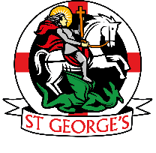
St. George’s Catholic Primary School
To learn with kindness, respect and friendship through God’s love

